COMMUNITY
ENGAGEMENT
TRAINING OF TRAINERS MANUAL

FOR USE BY FRONT-LINE TRAINERS IN LEBANON

October 2019
Table of contents

ABBREVIATIONS LIST 3
I. Course Description 4
II. Training Agenda 8
III. DAY ONE 9
IV. DAY TWO 17
V. DAY THREE 23

ABBREVIATIONS LIST

C4D | Communication for Development
CBOs | Community Based Organizations
CE | Community Engagement
FW | Front-Line Workers
N/A | Not Applicable
NGOs | Non-Governmental Organizations
OJT | On-the Job Training
PPT | PowerPoint Presentation
SWOT | Strengths, Weaknesses, Opportunities, and Threats
TNA | Training Needs Assessment
TOT | Training of Trainers
UNICEF | The United Nations Children's Fund
VIPP | Visualization in Participatory Processes
WGs | Working Groups

Community Engagement
Training of Trainers (TOT) Manual

I. Course Description
- Introduction:
In today’s ever-changing marketplace, the importance of training has never been greater, placing the need for qualified trainers in different disciplines and topics specially the development and community development field in the centre. Being an effective trainer is a skill that the marketplace highly demands. It is important to realize that any trainer needs two sets of skills and knowledge:
- Need to know the topic they are teaching (subject matter expertise).
- Need to know how to transfer that information to others (instructional expertise) as adults training adults requires specific competencies.

The Training of Trainers Course will help you unleash your natural potential as a Trainer while giving you the basic, yet essential, skills needed to effectively train and capacity build frontline workers. In this program you will learn how to become a Community Engagement Trainer, develop effective training materials and how to understand, assess and address your audience.

The ToT will put you on the right track to being a professional trainer on community engagement. This course will provide you with methods and tools to ensure efficient learning process. It focuses on adult learning principles, and includes all stages of the learning cycle:
- Training Needs Assessment (TNA)
- Methods, techniques and tools to properly deliver a training course
- Training course follow-up.

This ToT Package is developed to be used in training potential trainers on community engagement working in Lebanon and affiliated with UNICEF, government counterparts and partners.

The “Learning Events” detailed in the Manuals are designed to bring all participants’ the same page, & to explore concretely how to develop better, stronger, & well focused CE interventions that are results-based, sustainable, using a human rights-based approach.

- The Goals and Objectives of the Course

By the end of the ToT course,
- participants would have understood the basics of adult learning methods, techniques and will be able to train frontline workers on Community engagement.
- Potential trainers (participants) will be able to design a training workshop, develop session plans, formulate training objectives, demonstrate different training methods suitable for Community Engagement, Explain & demonstrate the five Community Engagement steps and appropriate tools for each step
- Participants will be able to understand how to work effectively with refugees and host communities, towards planning and implementing programs through Community engagement
- Course Methodology
The training course is based on a series of sessions, which is adapted to the requirements of the course participants. The emphasis is placed on practice and exercises rather than on presentations to ensure gaining the maximum benefits from the workshop:
The following training methods will be utilized during the course:
- Group-work
- Brainstorming
- Role play
- Case Studies
- Field practice
- Evaluation of the course
The evaluation will depend on:
- Pre and Post Test, where participants will need to perform a test before the start of the course, and then perform the same test by the end of the course to see changes in knowledge and skills acquired through the course.
- Final Course Evaluation.

- Planning & Logistics for Conducting a Training Workshop
Great trainings don’t just happen; they require a great deal of advance preparation. If you are in charge of organizing a training, you will need to start preparation at least four weeks prior to the training. Training for a workshop requires preparation before the training, during the training and after the training.
- Preparing for the training
- At least 2-3 Weeks Prior to the training:
- Send out invitations.
- Reserve venue.
- Consider who will facilitate the training and make initial contact with them.
- 2 Weeks Prior to the training:
- Confirm participation of the facilitators and assign sessions.
- Print out facilitator guides and send to each facilitator.
- Prepare the Course Agenda and send to the facilitators.
- Trainer to review the training guide and session plans to ensure they are comfortable with the sessions, and that they can explain all the issues in the manual
- 1 Week Prior to the training:
- Confirm participant attendance.
- Purchase stationary: notebooks, marker pens, flipcharts, pens, nametags.
- Print out all handouts.
- Reserve equipment needed.
- The Day Before the Training:
- Pack all materials
- Check all equipment to ensure it is working properly.
- Hold Facilitators Meeting (led by the Course Coordinator):
- Confirm/Finalize the Course Agenda.
- Go over any questions on Content & Methods.
- Discuss expectations and the importance of teamwork.
- At the end of the meeting, go as a team and prepare the room set-up for the following day.
- During the Training
Room Set-Up
- Set up room in a U Shape and make sure there are round tables to accommodate small group work. (effective training should not have more than 25 participants)
- Set up a facilitators’ table and a table for hand-outs and supplies.
- Ensure availability of water and coffee breaks in the proper time as the training agenda.

- After the Training
- Evaluations:
- Review the Course Evaluations and compile the quantitative and qualitative data to enter into the training report.
- Incorporate the suggestions into the curriculum and into future trainings.
- Training Data:
- Prepare a table of training participants for the training report, using both the registration forms and the signing sheet.
- Enter the participant data into a training database using the registration forms.
- Training Report
- Develop a report post the training capturing the main issues raised or observed during the training.

II. Training Agenda

Session One  9:00 – 11:30 | Break  11:30-12:00 | Session Two  12:00-2:00 | Break  2:00-3:00 | Session Three  3:00-4:00 | Session Four  4:00-5:00
DAY ONE
- Welcome and introduction & (40 min)  - Pretest (15 min)  - Course description (15 min)  - Training Skills: Principles of adult learning & Training methods suitable for adult learning (80 min) | Coffee  Break | - The 3Vs of communication skills (90 min)  - Training Objectives/learning outcomes (30 min) | Lunch | - Energizer (10 min)  - Training lesson plans (50min) | - Energizer (5 min)  - Training Skills: Evaluation of training programs (55 min)
DAY TWO
- Energizer (5 min)  - Recap of day 1 (10 min)  - Introduction to Community Engagement (40 min)  - Energizer (5min)  - Step 1: Preparation (90 min) | Coffee Break | - Step 2: Assessment, problem identification and prioritization (120 min) | Lunch | Energizer (10 min)  Step 3. Design and Planning (110 min)
DAY THREE
- Energizer (15min)  - Recap of day 2 (15 min)  - Step 4 Implementation and Monitoring (90 min)  - Step 5: Evaluation (30 min) | Coffee  Break | - Energizer (10 min)  - Step 5 Evaluation (50 min)  - Wrap up exercise (60 min) | Lunch | - Energizer (10 min)  - Wrap up exercise (50 min) | - Post Test (10 min)  - Planning for Field practice (50 min)
DAY FOUR & FIVE | Field Practice

III. DAY ONE

Day 1 Activity 1 Welcome and introduction

Time0 - 10:30
Day 1  Activity 1 | Welcome and Introduction | Allocated Time  40 minutes
Learning objectives | - Welcoming of participants (official speeches)  - Introducing facilitator(s) and participants to each other  - Presentation of workshop expectations  - Agreeing on ground Rules for the training  - Understanding the training objectives
Training Methods | Speeches and Open Discussion  - Official speeches  - Ice breaker  - Brainstorming
Materials | - Printed Table Name Cards  - Podium  - Flipchart stand and papers  - Flipchart Pens
Preparation | - Printed Table Name Cards for facilitators, guests, and participants  - Flipchart labelled “EXPECTATIONS” and ground rules  - Flipchart Pens (2 sets of 4 colours)
Process | Introductions Ice breaker  - Prepare 15 quotes and split them into two parts (in case the total number of participants is 30). Write each half of the quote on a paper and place all papers in a bowl. Each participant needs to collect a piece, look for the person who has the other half of the quote. After being in pairs, participants will be given 5 minutes to get to know each other.  - Each participant will be required to introduce their partner/second half (name, organization, field of work, scientific background, hobbies, favourite animal, book, family, something they like, etc.) List of quotes that could be used:  طب الجرة عتما/البنت بتطلع لإما  لا تقول فول/ليصير بالمكيول  عصفور بالإيد/ولا عشرة عالشجرة  الصبر/مفتاح الفرج  ذكور الورد/وشم ريحتو  صافي/يا لبن  ألف كلمة جبان /ولا كلمة الله يرحمو  يلي بياكل العصي/ مش متل يلي بيعدها  إقعد أعوج/ وإحكي جالس  على قدّ بساطك/ مدّ اجريك  احترنا يا قرعة/منين بدنا نبوسك  الطفل يلي ما بيبكي/ما بترضعو إمو  القرد بعين إمو/غزال  الإيد اللي ما فيك تعضها، بوسها وادعي عليها بالكسر  يلّي بيتو من قزاز/ما يراشق الناس بحجارة  - Workshop expectations and ground rules  - Nominate one volunteer participant to help in writing participant’s expectations on a flipchart and ground rules on another flip chart  - Ask participant the following question” What are your expectations from this workshop? What do you want to achieve by the end of the training?  - Ask the participants to decide the ground rules and in another flipchart, paper labelled “GROUND RULES” write down their responses  - At the end of the activity, ask the volunteer participant to hang the “EXPECTATIONS”, and “GROUND RULES” flipcharts in front wall and keep it in place during the entire duration of the workshop

Day 1 Activity 2 Course description
Day 1  Activity 2 | Course Description and Pertest | Allocated Time  15minutes
Learning outcomes | By the end of the activity, participants will outline the ToT course objectives and examine the training overview
Training Methods | Presentation and Discussions
Materials | Course Description PPT
Preparation | Prepare the PPT, Projector, computer, and screen
Process | Present the following:  - Course purpose, objectives, topics, training methods, evaluation techniques, and agenda  The Goals of the Course  - To identify the basics of adult learning and be able to train a group of frontline workers in full respect of the contents of the Community Engagement Field Guide as well as methods, techniques and tools for adult learning.  - To be able to design a training session and to ensure a proper follow-up of a course for the frontline workers  The learning outcomes of the Course  By the end of this five days ToT course, participants will be able to:  - Summarize the basics of adult learning methods, techniques and will be able to train frontline workers on Community Engagement.  - Design a training workshop, develop session plans, formulate training objectives, demonstrate different training methods suitable for Community Engagement, Explain & demonstrate the five Community Engagement steps and appropriate tools for each step  - Detect how to work effectively with refugees and host communities, towards Community engagement  Note: Whenever appropriate, refer to participants’ expectations to show the similarities with the objectives  Pre-test  - Introduce the participant to the purpose of the pre-test:  - Help adjust training to suit participant knowledge level.  - Assess participant’s knowledge gaps to allocate more time and efforts during the workshop to enhance them  - Inform the participants that the same questionnaire will be used as post-test  - Inform the participants that the allocated time is 10 minutes  Distribute the pre-test forms (questionnaire) to the participants, and at the end of the allocated time collect the answered questionnaires. Please confirm that this is not a real test, it is only to gauge the level of knowledge for the participants on CE before and after the training
Annex | Annex 1. Pertest  Annex 2. Course Description PPT

Day 1 Activity 3: Principles of Adult Learning
Day 1  Activity 3 | Principles of Adult Learning | Allocated Time  80 minutes
Learning outcomes | By the end of the activity, participants will be able to:  - Discuss the three learning domains for adult learning  - Discuss the appropriate Learning Styles for adult learning  - Discuss Adult Learning Principals and qualities of good facilitation  - Utilize active learning training methods
Training Methods | Jigsaw (cooperative learning technique)
Materials | - Principles of Adult Learning and qualities of good facilitation Handout  - Training Methods suitable for Adult Learning Handout  - Flipchart stand, papers, and pens
Preparation | - Prepare copies of the “Principles of Adult Learning and qualities of good facilitation Handout” and “Training Methods suitable for Adult Learning Handout”.  - Prepare the PPT, Projector, computer, and screen.
Process | - Divide participants into Jigsaw groups of even numbers  - Give each person in the group a segment of the adult learning session  - Allow enough time for each member to review the topic of their segment  - Trainer should walk amongst the groups and lend support or explanation where necessary.  Step 1: Organize participants into 6 groups, each participant takes a number from 1 to 6  Step 2: Assign one participant in each group to be responsible for a different segment as follow:  - The three learning domains & The three primary learning styles → Participants with # 1  - Principles of Adult Learning & Motivating the Adult Learner→ Participants with # 2  - SIX Essential Skills of an Effective Facilitator→ Participants with # 3 (3 techniques 1-3)  - Training Methods suitable for Adult Learning, Participants with # 4  - Training Methods suitable for Adult Learning  Participants with # 5 (3 techniques 4-6)  - Training Methods suitable for Adult Learning Participants with # 6 (4 techniques 7-10)  Step 3: Give participants time to read and process their assigned segment independently.  Step 4: Put participants who completed the same segment together into an “Expert group” to talk about and process the details of their segment.  Step 5: Have participants return to their original “Jigsaw” groups and take turns sharing the segments they’ve discussed not experts already  Step 6: Ask participants some questions to ensure they understood the material from the contributions of all their group members.
Annexes | Annex 3. Principles of Adult Learning & Essential Skills of an Effective Facilitator Handout  Annex 4&5. Principles of Adult Learning & Essential Skills of an Effective Facilitator PPT  Annex 6. Training Methods Suitable for Adult Learning Handout (optional if needed)  Annex 7: Materials for JIGSAW Group work

Day 1 Activity 4: Communication skills
Day 1  Activity 4 | Communication skills | Allocated Time  90 minutes
Learning outcomes | By the end of the activity,  - Participants will discuss the principles of an effective communication  - Participants will describe the communication process  - Participants will summarize tips for an effective verbal, vocal, and visual communication
Training Methods | Interactive presentation and exercises
Materials | A4 papers and pencils
Preparation | - Prepare the PPT, Projector, computer, and screen
Process | Presentation and Brainstorming  - Explain the 5 principles of communication  - Discuss the components of the communication process  - Discuss tips to enhance verbal communication  - Discuss tips to enhance non-verbal communication (body language and voice)  Exercise  the facilitator will display 5 slides. Let each participant make a list of 5 items that he will first see in each slide. Discuss results (variation of lists among participants).  Discussion: the communication principles  Exercise: Mim: choose one volunteer who will try to transmit “I won the lottery” with gestures without speaking. Other participants need to decode. Discussion: communication process and its components based on the Ppt. Exercise: Memory test included in the PPT  Discussion: list tips to enhance verbal, vocal and visual communication
Annex | Annex 8. Communication skills PDF

Day 1 Activity 5: Communication skills
Day 1  Activity 5 | Energizer: Concentration | Allocated Time  10 minutes
Preparation | A spacious place where all participants can stand in 2 facing lines
Process | Arrange participants into two equal lines facing each other. Once group turns around while the other gets 30 seconds to change 10 things about them (switch jewelry, change hair style, untie shoelaces, switch watch to other arm, trade clothing, etc.) as long as they are all things in sight.  The first group turns back around and must identify the 10 changes. After they identify the changes, or time is up they swap so the other team gets to make changes while they guess.

Day 1 Activity 6 Training skills
Day 1  Activity 6 | Training Skills:  Common Understanding of Training Objectives and session plans | Allocated Time  80 minutes (30+50)
Learning outcomes | By the end of the activity,  - Participants will be able to identify the importance of training objectives/outcomes and their necessity  - Participants will be able to describe what are session plans and why they are needed
Training Methods | Presentation and brainstorming
Materials | What Is a Learning outcome? Session plans? Handout
Preparation | - Prepare copies of the “learning outcomes/session plans” Handout  - Prepare the PPT, Projector, computer, and screen
Process | Presentation and Brainstorming  - Explain the difference between training goals and objectives  - Explain the meaning of objectives  - Present some example of training goals and specific training objectives  - Ask the participants to formulate training goals and objectives  - Present the different models of session plans and explain why the need to use them for training  Group work  Split participants into 4 groups. Each group will choose one topic their NGO is working on and they will develop related goals, learning objectives, learning outcomes as well as one session plan as per the template number 4 (within annex 9 and 10). Each group will present its work and the other participants with the facilitator will give comments.
Annex | Annex 9. What Is a Learning outcome and session plans? Handout  Annex 10. What Is a Learning outcome? And session plan PPT

Day 1 Activity 7 Energizer
Day 1  Activity 7 | Energizer: Pink toe | Allocated Time  5 minutes
Process | The facilitator calls out a colour and a body part. Participants must find an object in the room that has that colour and then touch the object with the selected body part. For example, if the facilitator calls out “red nose”, participants need to find an object that is red and touch it with their nose. The facilitator continues calling colours and body parts.

Day 1 Activity 8 Evaluation of training workshops
Day 1  Activity 8 | Evaluation of Training Workshops | Allocated Time  55 minutes
Learning outcomes | By the end of the activity, participants will be able to evaluate a training program and list methods that can be used for training evaluation (tools)  - Pre and post-test questionnaire  - Training session evaluation, and final course evaluation forms
Training Methods | Interactive Presentation and group work
Materials | - Evaluation of Training Handout  - Flipchart stand, papers, and pens
Preparation | - Prepare copies of the “Evaluation of Training” Handout  - Prepare the PPT, Projector, computer, and screen
Process | - Group work: divide participants into 4 groups. The assignment is to evaluate the first day of the current training. Participants in each group need to suggest methods and tools for the evaluation.  For each Method/tool, they need to mention:  - What aspect of the training is this method/tool looking at?  - What are the criteria to make it successful and relevant?  - What should it include?  - Distribute a copy of the “Evaluation of Training” Handout” to each participant  - Present with explanation the methods used in evaluation of training workshops
Annex | Annex 11. Evaluation of Training Handout  Annex 12. Evaluation of Training PPT
30

IV. DAY TWO

Day 2 Activity 1 Energizer
Day 2  Activity 1 | Energizer: Find someone wearing... | Allocated Time  5 minutes
Process | Ask participants to walk around loosely, shaking their limbs and generally relaxing. After a short while, the facilitator shouts out “Find someone...” and names an article of clothing. The participants have to rush to stand close to the person described. Repeat this exercise several times using different types of clothing.

Time0 1

Day 2 Activity 2 Introduction to the Community Engagement

Day 2  Activity 2 | Introduction to Community Engagement (CE) | Allocated Time  40 minutes
Learning outcomes | By the end of the activity, participants will be able to:  - Identify what is the difference between community engagement, community mobilization, frontline workers, and campaigns  - Define What is a community  - Discuss What triggers community engagement  - Discuss the importance of community engagement  - Describe the process of Community Engagement
Training Methods | Brainstorming and presentation
Materials | - Introduction to Community Engagement  - Flipchart stand, papers, and pens
Preparation | Prepare the PPT, Projector, computer, and screen
Process | Ask the following questions (5 minutes for each question)  - What is a community?  - What is community Engagement? What is community mobilization?  - What is a frontline worker? What is a campaign?  - What triggers community engagement?  - What is the importance of community engagement?  - What is the process of community engagement  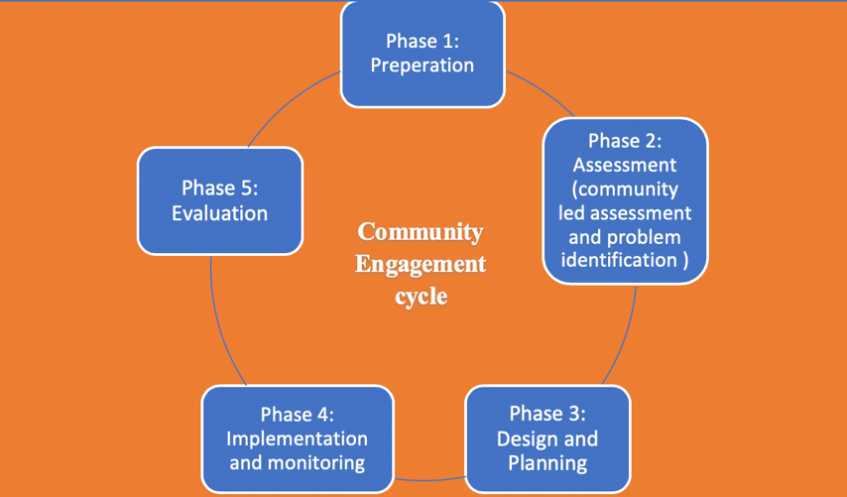  Ask the questions and write down participant’s answers and responses on the flipchart. At the end of the activity, present the Power Point presentation and refer to participant’s responses whenever appropriate
Annex | Annex 13. Introduction to Community Engagement - Part 1 “Definitions” PPT

Day 2  Activity 3 | Energizer : Bring me | Allocated Time  5 minutes
Preparation | None
Process | Participants sort themselves into small teams, and the teams stand as far as possible from the facilitator. The facilitator then calls out “Bring me...”, and names an object close by. For example, “Bring me a man’s or woman’s shoes.” The teams race to bring what has been requested. You can repeat this several times, asking the teams to bring different things.

Day 2 Activity 3 Energizer

Day 2 Activity 4 Phase 1 Preparation

Day 2  Activity 4 | Phase 1- Preparation | Allocated Time  90 minutes
Community Engagement Cycle
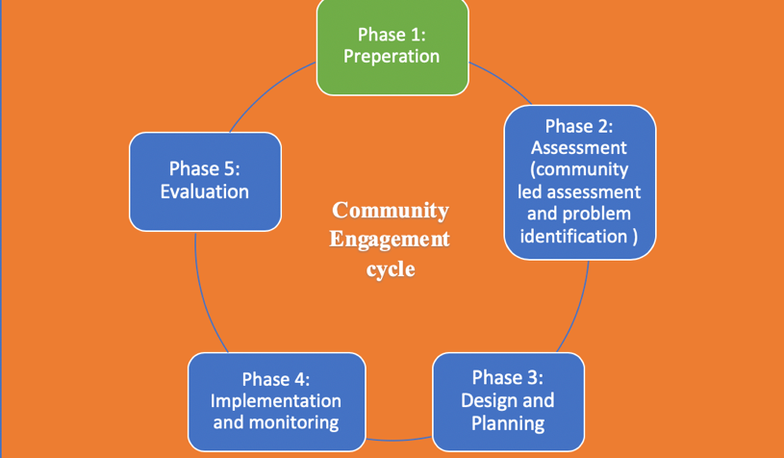

Learning outcomes | By the end of the activity, participants will be able to:  - Discuss fundamental steps in community engagement  - List community engagement five phases  - Discuss CE Phase 1: preparation
Training Methods | Interactive Presentation and Role play exercise
Materials | - Flipchart stand, pens, and papers  - Preparation PPT
Preparation | - Prepare the PPT, Projector, computer, and screen
Process | - By using the power point presentation, discuss and explain the following:  - Introduce the participant to the importance and significance of engagement of all segments of the targeted beneficiaries, gatekeepers, governmental and non-governmental organizations in all CE steps  - Briefly explain the five community engagement steps and ask some of the participants to list the five steps  - Explain the importance of preparation  Group work and role play  Split participants into three groups and ask each group to prepare for a community engagement process  Group 1: Waste management problem in and IDP camp  Group 2: Malnutrition for under 5 children in Baalbek  Group 3: low enrolment rates in preschool education in Sour  Each group will need to do the needed preparation to start the CE process then role play it to the rest of the participants  This will include:  - Mapping of Key stakeholders  - identification of partners, leaders, influential, and marginalized groups  - Planning start up meetings, meetings with local leaders, service providers and others who may be important for the CE process  - Selecting and training volunteers that will help in the CE process
Annex | Annex 14- Preparation  Annex 15: role play exercise

Day 2 Activity 5 Phase II Assessment

Day 2  Activity 5 | Phase II- Assessment | Allocated Time  120 minutes
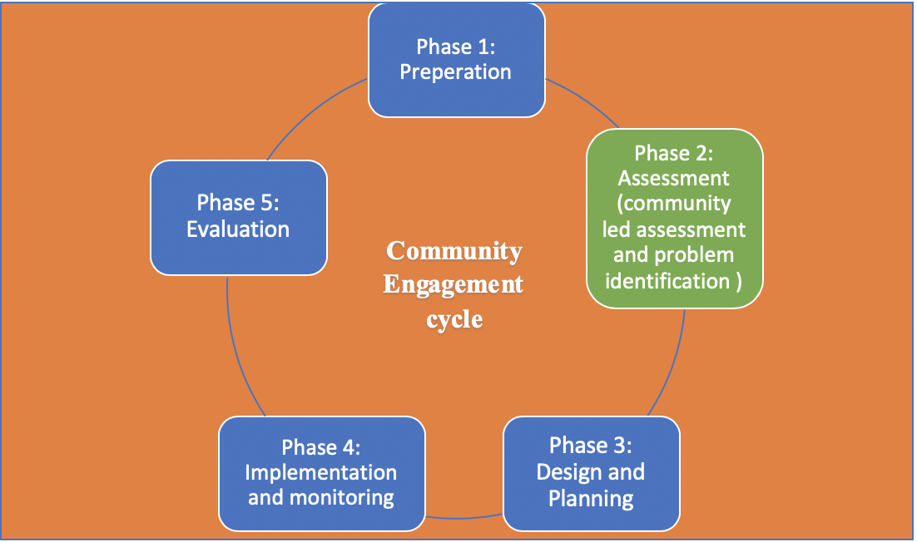
Learning outcomes | By the end of the activity, participants will be able to:  - Discuss fundamental steps in the community-Led Assessment  - Identify Community-Led Assessment Tools
Training Methods | Interactive Presentation and group work
Materials | - Flipchart stand, pens, and papers  - Assessment PPT
Preparation | - Prepare the PPT, Projector, computer, and screen
Process | By using the PowerPoint presentation, discuss and explain the need for assessment and the different approaches/techniques that can be used to carry out the assessment  Followed by Group work  The three groups who started to work on 3 different topics for the preparation phase, will continue on working on the assessment, in different techniques, as per the following:  - Group 1: Waste management problem in and IDP camp: Search and review existing information, Mapping, Community meetings, SWOT analysis  - Group 2: Malnutrition for under 5 children in Baalbek: Search and review existing information, Problem tree analysis, Participatory action research (PAR)  - Group 3: low enrolment rates in preschool education in Sour: Child Led Data Collection tool, mapping, Windshield Survey, Plan and undertake Studies and Surveys
Annex | Annex 16. Assessment PPT  Annex 17 Community mapping  Annex 18: Assessment and evaluation techniques

Day 2 Activity 6 Energizer
Day 2  Activity 6 | Energizer: “SAY WHAT I SAY, AND DO WHAT I SAY.” | Allocated Time  10 minutes
Preparation | A spacious place where all participants can stand in a circle
Process | - Form a circle, holding hands, facing in to the centre.  - Announce that you want the group to – “SAY WHAT I SAY, AND DO WHAT I SAY.”  - Practice this skill with one of four commands – “JUMP IN,” “JUMP OUT,” “JUMP LEFT” or “JUMP RIGHT.”  - Call out a series of ‘Jump’ commands, one after another for 20 seconds.  - Re-form the circle, and announce that you now want the group to – “SAY WHAT I SAY AND DO THE OPPOSITE OF WHAT I SAY.”  - Continue with a series of ‘jump’ commands, one after another for 20 seconds, or until the circle breaks up too much.  This exercise is almost impossible not to mess-up – which is the whole point. I promise you, this Jump in Jump Out game WILL cause your group to laugh out loud.

Day 2 Activity 7 Phase III Design and Planning
Day 2  Activity 7 | Phase III- Designing and Planning | Allocated Time  110 minutes
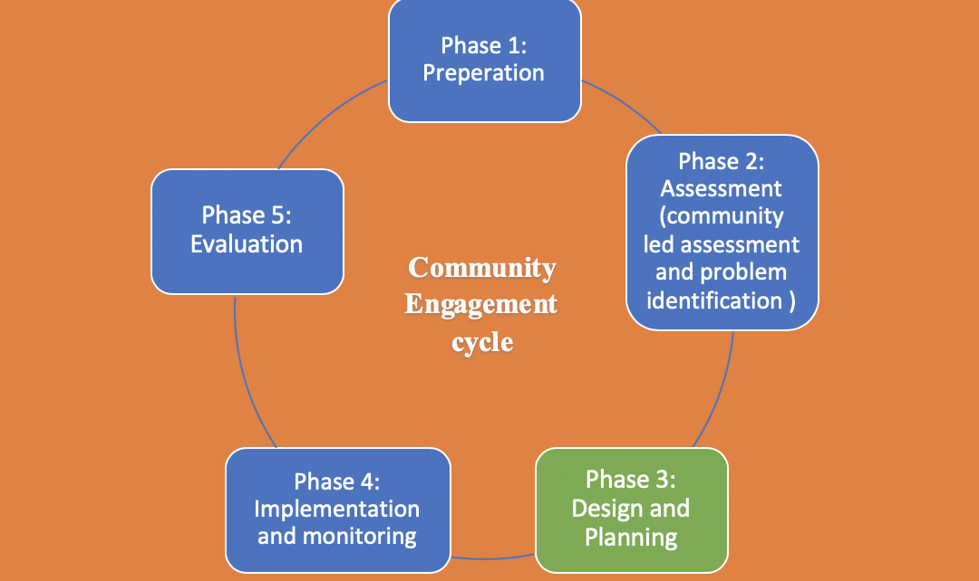
Learning outcomes | By the end of the activity, participants will be able to:  - Discuss fundamental steps in design and planning of CE interventions  - Identify the difference between goals, objectives and outcomes  - Develop an implementation plan
Training Methods | Interactive Presentation and group work
Materials | - Flipchart stand, pens, and papers  - Design and planning PPT
Preparation | - Prepare the PPT, Projector, computer, and screen
Process | By using the PowerPoint presentation, discuss and explain design and planning phase  Followed by Group work  - Keep the division of working groups like previous activity and based on their assessments, ask each group to develop  - Goals, Objectives, outcomes and the implementation plan
Annex | Annex 19: Designing and planning

V. DAY THREE

Day 3 Activity 1 Energizer
Day 3  Activity 1 | Energizer : People Bingo | Allocated Time  15 minutes
Preparation | Print out and distribute for each participant a People Bingo form (Annex 20)
Process | The facilitator will give each participant one People Bingo sheet. The will have 5 minutes to move around and search for people who fit according to what is given in the below form. The one who finishes first will say “Bingo”. Participants with the facilitator discuss the gathered data.
Annex | Annex 20 People Bingo

Day 3 Activity 2 Phase IV Implementation and monitoring

Day 3  Activity 2 | Phase III- Implementation and monitoring | Allocated Time  90 minutes
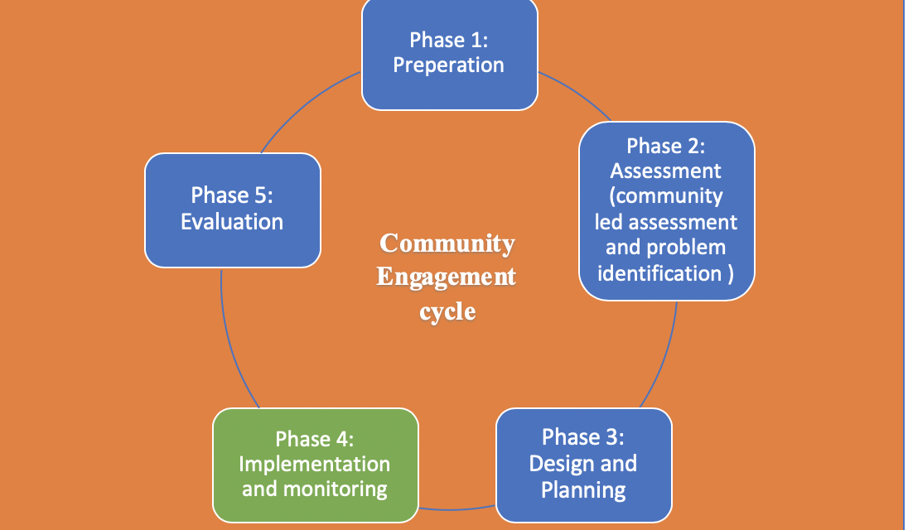
Learning outcomes | By the end of the activity, participants will be able to:  - The critical steps of implementation and monitoring  - Know the different monitoring techniques
Training Methods | Interactive Presentation and groups work
Materials | - Flipchart stand, pens, and papers  - Implementation and monitoring PPT
Preparation | - Prepare the PPT, Projector, computer, and screen
Process | By using the PowerPoint presentation, discuss and explain implementation and monitoring  Followed by Group work  - Keep the division of working groups like previous activity and based on the implementation plans developed, ask each group to work on the implementation methods, and monitoring techniques
Annex | Annex 21: Implementation and monitoring

Day 3 Activity 3 Evaluation
Day 3 Activity 3 | Phase V: Evaluation | Allocated Time  80 minutes  (30+50)
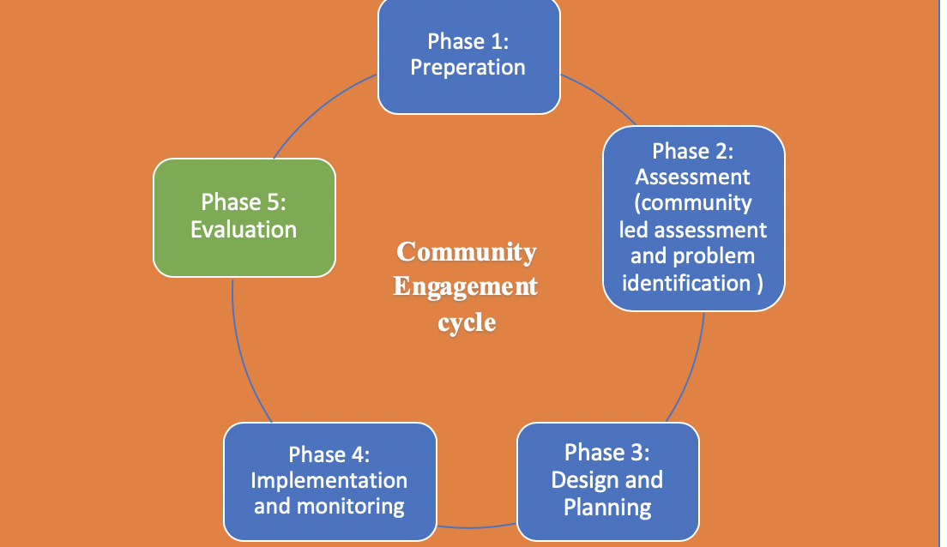
Learning outcomes | By the end of the activity, participants will be able to:  - Understand the value of assessments and evaluation  - Know the different types of evaluation and how it can be implemented
Training Methods | Interactive presentation and group work
Materials | - Flipchart stand, pens, and papers
Preparation | - Evaluation PPT  - Prepare a copy of the needed tools to each participant
Process | By using the PowerPoint presentation, discuss and explain evaluation, value and the need for it, followed by types of evaluation  Followed by Group work  - Keep the division of working groups like previous activity and based on the implementation plans developed, ask each group to work on the evaluation for their CE project
Annex | Annex 22: Evaluation

Day 3 Activity 4 Energizer
Day 3  Activity 4 | Energizer: Who Am I? | Allocated Time  10 minutes
Preparation | Papers equal to the participants’ number, with a name of a famous person on each. Tape is needed to put papers on participants’ backs
Process | - The leader tapes the name of a famous person on the back of each participant. (i.e. Fred Flintstone, Mary Lou Retton, Bill Clinton, etc.) The group member is not to see who is taped to their back. Their task is to find out who they are. The participants go around the room asking others only yes or no questions. If the member receives a "yes" answer, they can continue to ask that person questions until they receive a "no" answer. Then they must continue on to ask questions to someone else. When a group member figures out who they are, they take off the tag, put it on the front of their shirt, and write their own name on it. That person can then help others find out who they are. The exercise concludes when everyone has discovered who they are.  - List of famous persons that could be useful:  صباح، فيروز، وديع الصافي، مايكل جاكسون، الرئيس ميشال عون، الرئيس سعد الحريري، الرئيس نبيه بري، نجوى كرم، وائل كفوري، جبران خليل جبران، رودي رحمة، مارسيل غانم، راغب علامة، كاظم الساهر، أم كلثوم، الرئيس دونالد ترامب، هيفا، باسم فغالي، مستر بين، تشارلي تشابلن، دريد لحام، جورج خباز، ملحم بركات...

Day 3 Activity 5 Wrap Up Exercise
Day 3 Activity 5 | Wrap Up Exercise | Allocated Time  110 minutes  (60+50)
Learning outcomes | By the end of the activity, participants will be able to:  - Apply theoretically the 5 steps of community engagement into a specific topic
Training Methods | Group work /Display
Materials | flipchart papers, tape, markers, A4 papers
Preparation | Copies of the case study
Process | - Divide the participants into 4 groups.  - Each group will have a copy of the same case study  - During one hour, and after reading the case, the group will apply the CE process (5 steps) in order to appropriately mobilize the community and find a solution to the described problem  - During the next 50 minutes, groups will present their plan of action  - Participants as well as facilitators will give comments on the proposed plan
Annex | Annex 23. case study

Day 3 Activity 6 Wrap Up Exercise
Day 3  Activity 6 | Energizer: سوق عكاظ | Allocated Time  10 minutes
Preparation | None
Process | Divide participants into 2 groups.  The first group starts to sing a song. When they finish, participants of the second group need to sing a song that starts with the ending letter of the previous group’s song. And so on, until one of the groups wouldn’t be able to find a song that fits the criteria.

Day 3 Activity 7 Post test
Day 1  Activity 2 | Post test | Allocated Time  10 minutes
Process | Post-test  - Remind participant to the purpose of the post test  - Inform the participants that the allocated time is 10 minutes  Distribute the post-test forms (questionnaire) to the participants, and at the end of the allocated time collect the answered questionnaires. Please confirm that this is not a real test, it is only to gauge the level of knowledge for the participants on CE before and after the training
Annex | Annex 24 Post test

