COMMUNITY ENGAGEMENT
TRAINING OF TRAINERS

FOR USE BY FRONT-LINE TRAINERS IN LEBANON

Assessment Methods Samples
- Problem Tree

Retrieved from: http://www.fao.org/fileadmin/user_upload/food-security-capacity-building/docs/Nutrition/Jordan_Workshop/3._FAO_Malnutrition_Problem_Tree.pdf
Example:
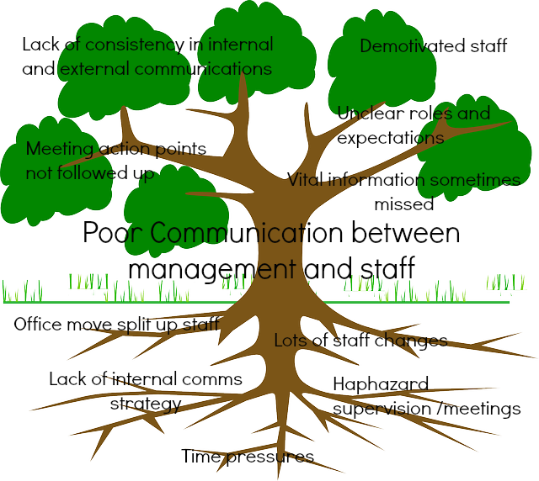

Retrieved from: https://www.jewellfacilitation.com/getting-to-the-root-of-the-problem/

- SWOT Analysis

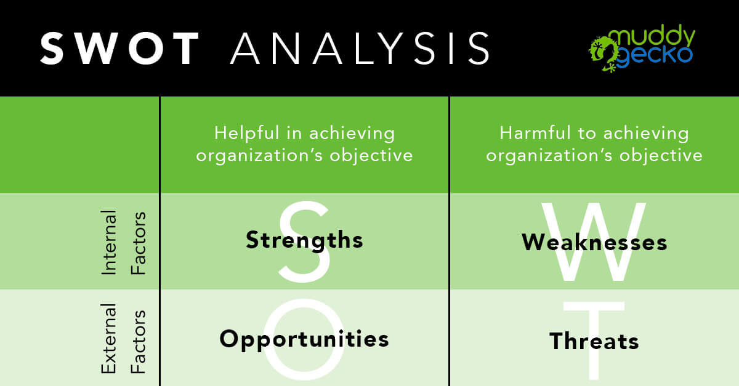

Retrieved from: https://www.muddygecko.com/2018/04/09/swot-analysis/

Example:
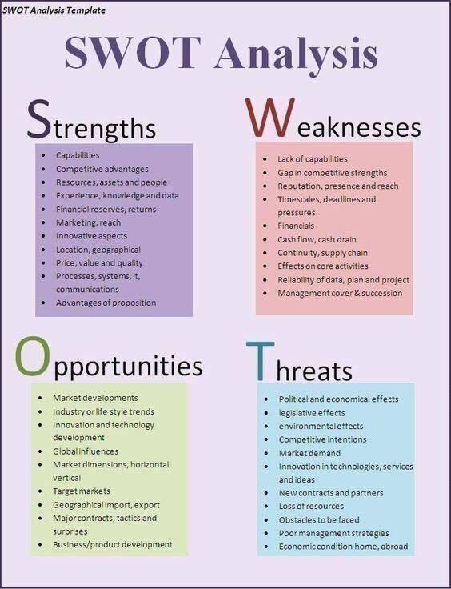
Retrieved from: http://templatelab.com/swot-analysis-templates/
- Windshield Survey

Retrieved from: Anderson, E., Mcfarlane, J,. (2011). Community As Partner: Theory and Practice in Nursing. Wolters Kluwer - Lipincott. 6th Edition. Page 175

