

**COMMUNITY ENGAGEMENT**

**TRAINING OF TRAINERS**

**FOR USE BY FRONT-LINE TRAINERS IN LEBANON**

**Mapping the Community**

**Objective:**

* Empower and support the community leaders in learning about their community "as they see it now”.
* They will “see” themselves through the tangible and graphic representation that they create themselves.

**Materials needed:**

Whatever local materials are available (or large pieces of paper and marking pens).

**Process:**

1. Get together with community leaders to explain the process.
2. Ask the leaders to call a meeting of the community members who would be interested in explaining or diagramming their community
3. At the meeting discuss life in the community to create a friendly atmosphere
4. Ask the community to draw/construct a map of their community, showing the location of houses, other buildings, river, farmlands, etc. – including any special topic, such as health (and the locations and persons important to health)
5. When completed, review the map together as a group and make corrections until everyone is satisfied
6. Discuss features of the map, e.g. clustering of houses, location of school, shops, etc.

**Additional Process:**

1. Analyze important features, e.g. why are many houses near the river? Why are some houses near the farmlands?
2. Make some comparisons, e.g. where are the healthier families located? where are the latrines? are immunized families often healthier families
3. Make a few hypotheses, e.g. is immunization related to health? Is economic status related to health?

**Please see following page for one possible results of a community mapping exercise. In this case it is a health-related map but it could be adapted for any intervention.**

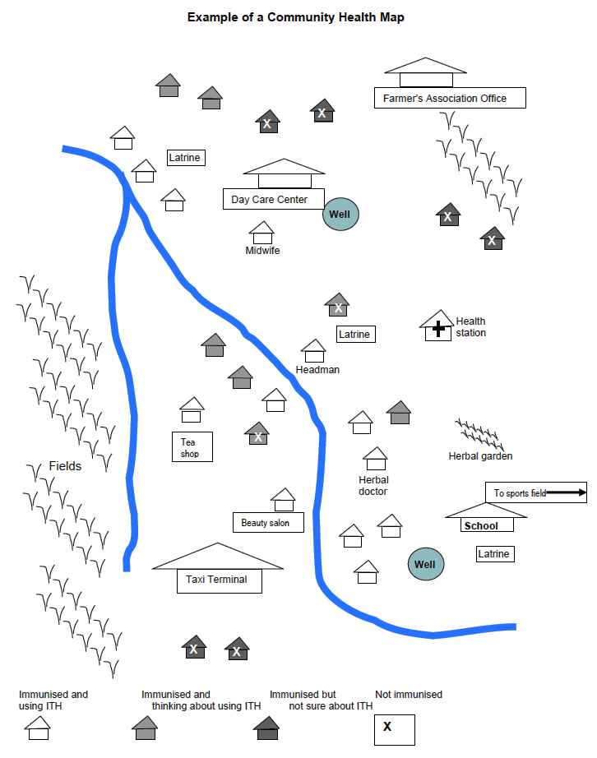**Example of a Community Health Map**

**Objectives:**

* 1. To enrich the community’s information sketched on the map
  2. To demonstrate the importance of going in person – as a team – to observe and talk about issues of local importance.

**Materials** **needed**:

Small notebooks, pens, large sheets of paper with the map drawn on them

**Process:**

* 1. On the map which the community has drawn, divide it geographically into sections. In this case we have divided it into four quadrants.
  2. Divide into smaller groups and ask community members to lead through the quarters.
* Speak to people you meet
* Observe conditions and note any differences (positive or negative) between what has been drawn on the map, stated by the community, or contained in any other data sources.
* After the walk, gather into small groups and discuss what has been seen.
* You may want to conduct a Force Field Analysis based on what has been seen, as well as conducting an Appreciative Inquiry exercise.