Event Report

Policy Dialogue on Menstrual Hygiene Management (MHM) Tax Reforms
(August 07 2023-Serena Hotel, Quetta)

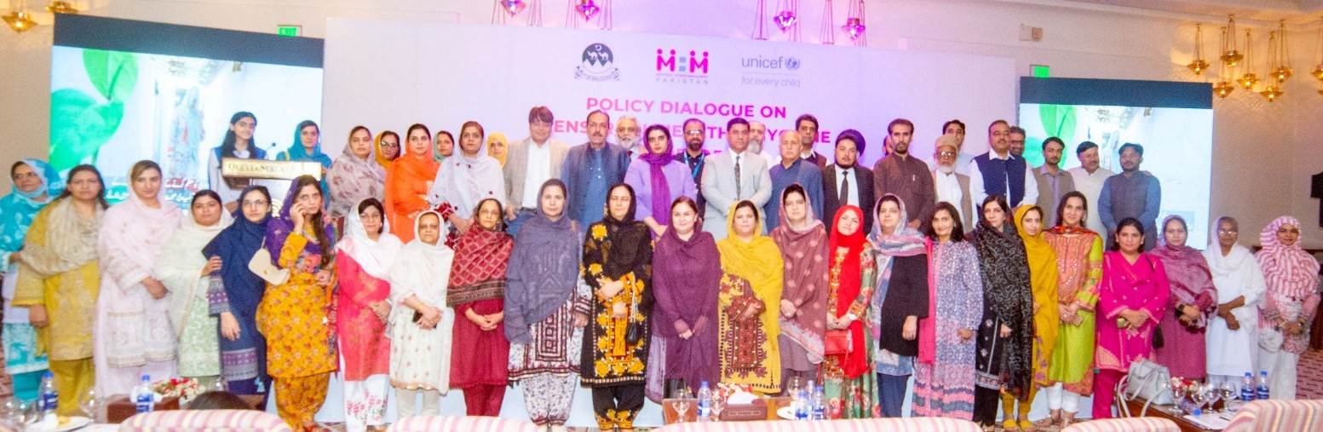

Compiled and submitted by:
Shafqat Aziz-Senior Communications Specialist-Trainer

Background:
The Policy Dialogue on Menstrual Hygiene Management (MHM) Tax Reforms, held in Quetta on August 7, 2023, marked a significant milestone in the ongoing efforts to advance menstrual hygiene management and promote gender equality in Pakistan. Menstrual hygiene management has emerged as a critical aspect of women's health and well-being, yet it often faces challenges stemming from social taboos, lack of access, and financial barriers, including taxes on menstrual products.
Importance of Menstrual Hygiene Management (MHM) in Pakistan:
In Pakistan, like in many parts of the world, menstrual hygiene management remains an important but often overlooked aspect of women's health. Access to safe and hygienic menstrual products, as well as proper education about menstruation, is crucial for the overall well-being and dignity of women and girls. However, several factors, including societal norms, economic constraints, and inadequate awareness, have led to a lack of proper MHM practices.
The Impact of Period Tax:
One of the notable challenges in this context is the imposition of taxes on menstrual products, often referred to as the "period tax." These taxes contribute to making menstrual products less affordable and accessible, particularly for marginalized communities. The financial burden created by such taxes can disproportionately affect women and girls who already face economic challenges.
Collaborative Efforts:
Recognizing the urgency of addressing these challenges, the MHM Working Group (MHMWG) Balochistan, UNICEF, and Qatar Charity, jointly organized the Policy Dialogue on MHM Tax Reforms. This event brought together a diverse range of stakeholders including policymakers, experts, advocates, and community members to collectively address the multifaceted issues surrounding menstrual hygiene management and explore innovative solutions.
Event's Objectives:
The primary goal of the policy dialogue was to highlight the importance of comprehensive menstrual hygiene management measures and advocate for transformative tax reforms that can positively impact women's health and well-being. By removing or reducing taxes on menstrual products, the aim was to alleviate the financial burden on women and families, while also fostering a conducive environment for open discussions about menstruation.

Key Themes and Discussions:
The event commenced with enlightening speeches from esteemed speakers who emphasized the significance of menstrual hygiene management in achieving gender equality and social progress. These initial remarks set the tone for engaging panel discussions and workshops that followed. Participants delved into critical topics such as affordability, accessibility, stigma reduction, education, and the intersectionality of MHM with various aspects of development.
The panelists from diverse technical backgrounds were including Federal Board of Revenue, Health, Education, Population, and Women Development departments, media and civil society were engaged in discussions on various challenges related to menstrual hygiene management, including affordability, accessibility, and the stigma surrounding menstrual products. The role of tax reforms in addressing these challenges was a central focus. The policy dialogue also recognized the intersectionality of MHM with education, health, and women's empowerment, acknowledging its pivotal contribution to sustainable development.
In her opening remarks during the Policy Dialogue on Menstrual Hygiene Management (MHM) Tax Reforms, Dr. Tahira Kamal, the Chairperson of the MHM Working Group (MHMWG) in Balochistan, shed light on the pervasive challenges faced by the province in the domain of menstrual hygiene management. With a focus on both the obstacles and the collaborative efforts undertaken to address them, Dr. Kamal provided a comprehensive overview of the situation.
Dr. Kamal began by underscoring the unique challenges that Balochistan faces in terms of menstrual hygiene management. The province, characterized by its diverse and often remote communities, has encountered significant barriers in ensuring proper menstrual hygiene practices among its women and girls. Economic constraints, limited access to resources and education, cultural taboos, and insufficient awareness have collectively contributed to a situation where many individuals are denied their right to dignified menstrual health.
Dr Kamal went on to highlight the concerted efforts that have been undertaken to address these challenges. She acknowledged the support extended by various organizations including UNICEF, GIZ (German Corporation for International Cooperation), Qatar Charity, and other members of the MHMWG. Through these collaborative partnerships, significant strides have been made in raising awareness and empowering communities to confront the issues surrounding menstrual hygiene.
Ms Mahjabeen Sheeran, the Parliamentary Secretary to the Chief Minister of Balochistan, drew attention to the significant economic implications of reforms related to menstrual hygiene management. Her insights shed light on how these reforms could not only improve the lives of

women and families but also contribute to broader economic growth and prosperity within the region.
She underscored the financial challenges faced by women and families in Balochistan due to the existing taxes on menstrual products. She highlighted how these taxes contribute to making these essential items less affordable, disproportionately affecting women from marginalized communities. By drawing attention to this aspect, Ms Sheeran conveyed a deeper understanding of the day-to-day struggles that many women and families endure to ensure access to necessary menstrual products.
In a poignant address during the Policy Dialogue, Dr M Amiri Hamayun, the Chief Field Office of Balochistan for UNICEF, articulated a profound perspective on the significance of menstrual hygiene management. Dr Hamayun's remarks not only shed light on the multi-faceted nature of this issue but also demonstrated UNICEF's unwavering commitment to fostering positive change in Balochistan through collaborative efforts and policy reforms.
His address was the recognition of tax reforms as a potential catalyst for achieving gender equality and social progress. He positioned these reforms as a collaborative endeavor, echoing the sentiments of a united effort by stakeholders, communities, and policymakers to create an environment that empowers women and girls. Highlighting UNICEF's commitment to the cause, Dr Hamayun affirmed the organization's dedication to supporting MHMWG Balochistan for the policy dialogue and the broader campaign for menstrual hygiene rights. Through his words, he communicated UNICEF's intention to be an enduring partner in the journey towards a more equal, informed, and dignified society in Balochistan.
Former Speaker of the Balochistan Assembly, Ms. Rahila Durrani, emphasized the vital role of awareness in MHM advocacy. Breaking taboos surrounding menstruation and providing proper education about hygiene were identified as essential. Tax reforms were seen as a means to facilitate better access to information and resources.
Yasmin Lehri, a senior parliamentarian representing the National party, emphasized the imperative of raising awareness as a means to confront the issue of stigma and prevailing social attitudes. She underlined the significance of shedding light on the challenges associated with menstrual hygiene management, thus initiating a broader dialogue on the matter.
Similarly, Shama Ishaq, another senior parliamentarian articulated that tax reforms possess the potential to act as a catalyst in dismantling the entrenched societal taboos that surround menstruation. By creating an enabling environment through these reforms, Shama Ishaq

expressed her belief that society can be encouraged to foster open conversations and embrace inclusivity, ultimately transforming the discourse on menstrual health.
Mr Rahmatullah, the Commissioner of the Federal Board of Revenue (FBR) in Quetta, shared his valuable insights during the policy dialogue. He proposed the idea of a subsequent mutual consultation, focusing on the technical aspects. This consultation would explore methods to categorize MHM products separately from luxury items, thereby facilitating a reduction in taxation.
Mr Abdul Wahid Shakir Baloch, Director Education, informed the participants that the government will consider the proposal that MHM should be included in the Cluster Budget of the Education Department, Ms Zulaikha Buledi, Additional Director, and Education, highlighted the importance of collaborated efforts for the promotion of MHM.
Ms Kiran Qazi, WASH Officer UNICEF, presented an overview of the menstrual health and hygiene tax reforms in Pakistan while Ms Erum Adnan, representing Santex, provided an analysis of the impact of taxes on the affordability and accessibility of MHM products.
The panelists including Abdullah Khan, Secretary Population, Mr Sikandar Shah, Secretary WDD, Dr Farooq Azam, Irfan Awan, Dr Atta-ur-Reham, Mr Jasbir Singh, Director General Health Noor Muhammad Qazi, Mir Rehmat Salah, former Minister for Health, Senior Journalist Shahzada Zulfiqar, Ejaz-ur-Rehan from Qatar Charity, and representatives from various line departments stressed the significance of a regular media campaign to highlight the issue of menstrual hygiene management. They acknowledged that consistent media engagement and awareness programs can play a pivotal role in breaking the silence and destigmatizing menstruation. Such efforts are essential to raise public consciousness and garner support for MHM tax reforms.
The panelists reiterated their commitment to a sustained media campaign, advocating for increased media coverage and public discussions on menstrual hygiene management. They stressed that by leveraging the power of media, they aim to create a society that is more informed, empathetic, and supportive of women's menstrual health needs.
The Policy Dialogue on Menstrual Hygiene Management (MHM) Tax Reforms concluded with a call to action, urging policymakers to take decisive steps in implementing comprehensive tax reforms that support menstrual hygiene management and the rights of women and girls. The event's outcomes will be compiled into a comprehensive report, shared with relevant authorities, and disseminated among stakeholders to facilitate evidence-based decision-making.

Recommendations
The Policy Dialogue on Menstrual Hygiene Management (MHM) Tax Reforms, held in Quetta on August 7, 2023, not only highlighted the urgent need for comprehensive MHM measures but also emphasized the role of continued dialogue, stakeholder engagement, and sustained media campaigns to drive change and advocate for MHM rights. Drawing inspiration from the insights shared by esteemed speakers and panelists, the following recommendations are put forth:
Continued Dialogue Process:
The event's success lay in its role as a catalyst for continued dialogue. Stakeholders should commit to regular meetings and discussions, ensuring that the momentum created during the policy dialogue is maintained. By fostering an ongoing exchange of ideas, strategies, and updates, a collaborative environment can be sustained to address MHM challenges effectively.
Comprehensive Stakeholder Engagement:
Stakeholders from diverse sectors, including policymakers, experts, advocates, and representatives from line departments, should collaborate more closely. This collaboration should extend beyond formal events to encompass workshops, brainstorming sessions, and task forces. Engaging a broad spectrum of voices enriches the dialogue and helps craft holistic solutions.
Sustained Media Campaign:
The power of media in creating awareness and driving change cannot be underestimated. Stakeholders should unite in launching and sustaining a consistent media campaign that highlights the importance of MHM. This campaign should challenge taboos, promote open conversations, and spread accurate information about menstrual hygiene, eroding stigma and fostering societal acceptance.
Likewise, by highlighting success stories, showcasing community testimonials, and showcasing the benefits of MHM tax reforms, media engagement can compel decision makers to take swift and affirmative action.
Multi-Format Information Dissemination:
Stakeholders should focus on creating simplified Information, Education, and Communication (IEC) materials that cater to diverse audiences. These materials, ranging from pamphlets to infographics and videos, should communicate the importance of MHM, the rationale behind tax reforms, and the positive impact on women's health and economic empowerment.
Elevating MHM Awareness in Educational Institutions:
Collaborative efforts should be directed towards integrating MHM awareness programs into educational curricula. By fostering understanding and acceptance from a young age, the cycle of stigma can be broken, and positive attitudes towards menstrual health can be cultivated.
Catalyzing Advocacy through Collaborative Research:
Collaborative research efforts should be undertaken to provide robust data and evidence that supports the call for tax reforms and MHM measures. This research can be instrumental in engaging with policymakers and substantiating the case for reform with concrete facts and figures.
Promoting Equitable Taxation for Menstrual Hygiene Products:
Subsequent mutual consultation between the stakeholders, especially with FBR should be held to deliberate on technical nuances. This consultation should be aimed to explore effective methods of categorizing menstrual hygiene products distinctly from luxury items within the taxation framework. By doing so, it can pave the way for an equitable taxation system that ensures affordability and accessibility to these essential products.
Amplifying Grassroots Engagement:
Stakeholders should work in close collaboration with grassroots organizations, community leaders, and local influencers. Engaging at the grassroots level ensures that awareness and advocacy efforts are tailored to the specific needs and cultural contexts of different communities.
Incorporating MHM into Health and Education Policies:
Collaborative advocacy should focus on integrating MHM considerations into broader health and education policies. By embedding MHM as a priority within existing frameworks, lasting change can be realized through institutional support and funding.
Ensuring Accountability:
Stakeholders should establish mechanisms to monitor the progress of policy implementation. Regular reviews and assessments should be conducted to ensure that the proposed tax reforms and MHM measures are being effectively executed and that the desired impact is being achieved.

Enhancing MHM Awareness through Standardized IEC Materials
In light of the Policy Dialogue's discussions, it is imperative to urgently standardize all existing Menstrual Hygiene Management (MHM) Information, Education, and Communication (IEC) materials while concurrently developing new, relevant resources. This harmonization will ensure consistent and accurate messaging across platforms, reaching diverse audiences effectively. By expediting the creation of comprehensive and user-friendly materials, this initiative will play a pivotal role in dismantling stigma, promoting open conversations, and fostering informed choices regarding menstrual health.
Building Strategic Partnerships:
Collaborative efforts should extend to forging strategic partnerships with influential organizations, institutions, and individuals. By pooling resources and expertise, a more comprehensive and impactful advocacy campaign can be launched.
Long-Term Advocacy Strategy:
The event's outcomes, compiled into a comprehensive report, should serve as the foundation for a long-term advocacy strategy. This strategy should outline clear goals, milestones, and methods for sustained engagement with decision makers and stakeholders, ensuring that the momentum generated from the policy dialogue translates into lasting change.
These recommendations align with the spirit of the Policy Dialogue on MHM Tax Reforms and serve as a roadmap for continued engagement, awareness building, and policy advocacy. By working collaboratively and adopting a multi-faceted approach, stakeholders can pave the way for improved menstrual hygiene management, gender equality, and women's empowerment in the region.

Annex-1

Media Coverage:
(Some glimpses of media coverage)

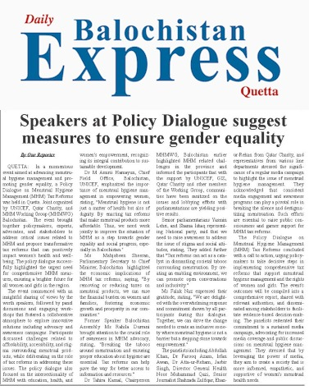

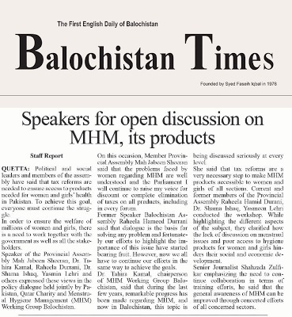

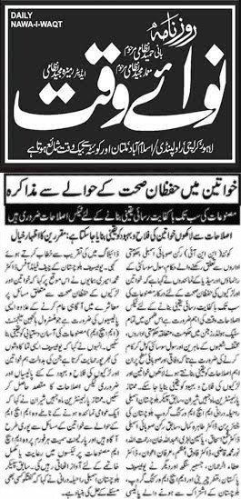

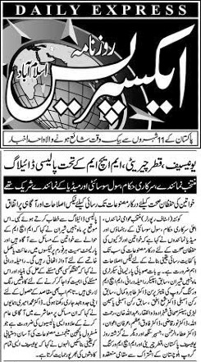

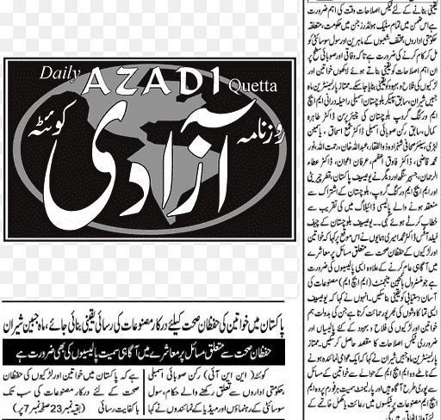

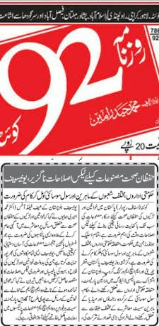

Online Insertions:
APP
https://www.app.com.pk/domestic/speakers-at-policy-dialogue-on-mhm-tax-reforms-suggest-measures-to-ensure-gender-equality/
Urdu Point
https://www.urdupoint.com/en/pakistan/speakers-at-policy-dialogue-on-mhm-tax-refor-1735494.html
Balochistan 24
https://www.balochistan24.com/07/08/2023/82364/

Annex-2

Policy Dialogue
on Menstrual Hygiene Management (MHM)Tax Reforms
Let’s Break the Silence
Hotel Serena, Quetta

A G E N D A
7 AUG, 2023
TIME | ACTIVITY | AIM / EXPECTED OUTCOMES | LEAD
09:30 am – 10:00 am | Arrival | - Registration  - Recitation from Holy Quran
10:00a m – 10:10 am | Welcome | - Welcome to participants and objectives of Tax reforms policy dialogue | Dr Tahira Kamal,  Chair, MHMWG Balochistan
10:10 am – 10: 20 am | key issues and challenges | - MHH related challenges in Balochistan and the existing efforts to address this taboo social issue at community level | Ms Zulaika Buledi,  Co- Chair MHM
10:20 am – 10:30 am | MHM-National & Regional Context | - Presentation on Menstrual health and hygiene tax reforms | Ms Kiran Qazi WASH Officer UNICEF ISB
10:30 am – 10:40 am | Making MHM products accessible to all | - Presentation by Sentax as Analysis of the impact of taxes on the affordability and accessibility of MHM products and Overview of any existing tax policies on exemptions | Ms Erum Adnan Santex
10:40 am – | Panel Discussions | - Need of Advocacy and Policy Recommendations, media and other stakeholders engagement | Ms Shahana Tabassum
10:40 am – 12:00 pm | Q&A | - Questions to Technical & policy makers panellists
12:00am  12:20 pm |  | - Questions to decision maker Parliamentarian panellists
12:20 pm – 12:30 pm | FBR’s Perspective | - MHM and the Prospects for the Tax Reforms | Mr Rahmat ullah khan Durrani, Commissioner Income Tax  -FBR
12:30 pm – 12:35 pm | Keynote address | Mobilizing Support and Building Alliances and Strategies for building alliances with relevant organizations, NGOs, and advocacy groups and the need of Exploration of partnership opportunities with policymakers, influencers, and the private sector | Ms Mahjabeen Sheeran MPA
12:35 pm – 12:40 pm | Vote of Thanks/Closing Remarks | With Expression of gratitude to the participants for their contributions and Encouragement for continued collaboration and commitment to advancing tax reforms on MHM products. | UNICEF
12:40 pm -–1: 00 pm | Group photo & Pledges
1:00 pm | Lunch

Annex-3
The Participants
