UNFPA-UNICEF Joint Programme on the Elimination
of Female Genital Mutilation: Delivering the Global Promise

Newsletter Entry

Activity 1
Activity Name | Community dialogues to protect girls from FGM
Description and/or outcomes | The Joint UNFPA/UNICEF Programme continues to support community dialogue as one of the regionally used strategies for community capacity building on the harmful impact that FGM and child marriage have on the lives of women and girls.  Quinara is the third region with the prevalence of 59 % of girls and women aged 15-49 years who have experienced FGM, 97 % are ethnic “Beafada” according to MICS6 2018-2019.  The joint mission with the implementing partners NGO RA (Rede Ajuda), CNAPN (National Committee for Abandoning Harmful Practices), allowed to strengthen community collaboration and participation in human rights-based community dialogues to end harmful practices, including FGM and child marriage.  Cadi, 16 years old – Sao Martinho, in Empada from Quinara Region  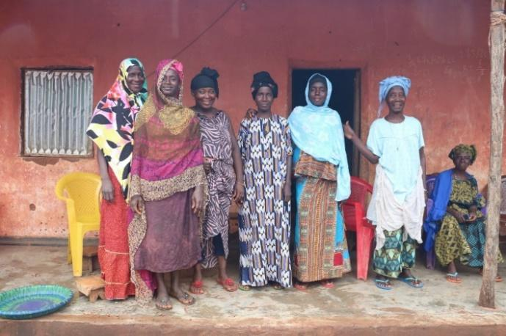  Women from the community of Sao Martinho, in Quinara, Guinea-Bissau, came together to participate in the community dialogues about practices that harm girls and women. They gathered around to talk to the men of the village, the imam and the head of the Tabanka (chief of the community) about ending female genital mutilation, forced marriage and child marriage. Everyone agreed that these practices must stop and that in this community no girl will suffer female genital mutilation again.  After the older women talked, it was time to hear Cadi. She is 16-year-old girl and has been helping the activists from the NGO Rede de Ajuda work in the community of Sao Martinho. Cadi participates regularly in the weekly meetings and activities, supported by the UNFPA-UNICEF Joint Programme on the Elimination of Female Genital Mutilation in Guinea Bissau. There they talk about different topics, like female genital mutilation, forced marriage, gender violence, and mistreatment of people with disabilities. She shares everything she learns with her schoolmates.  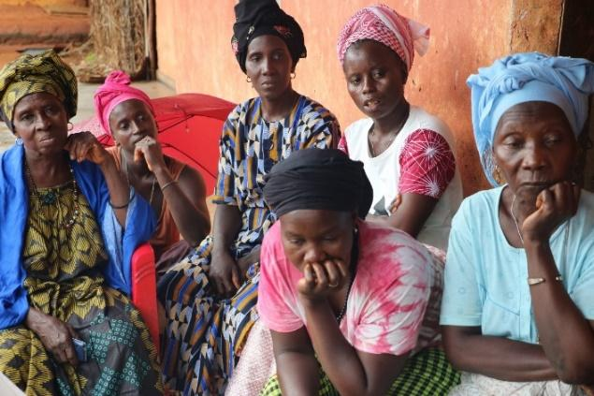  Sao Martinho is a new community identified for intervention for this year, the community dialogues started about 6 months ago and she already notices a change in people's behavior and attitudes. “Everyone avoids problems now”, she says.  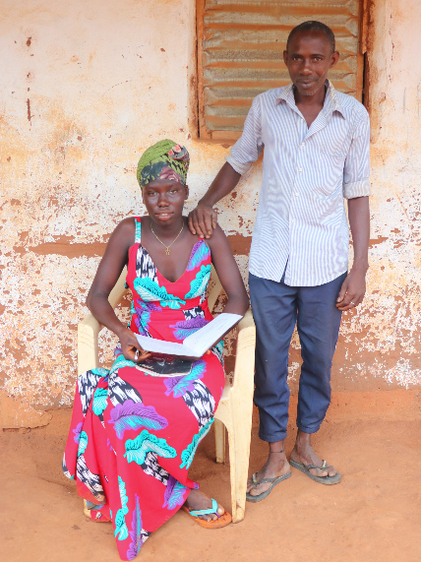  Her dream is to be a teacher and for that she knows she has to keep studying. Getting married is not in her plans until she is at least 18 years old. Luckily, Cadi’s family is also against forced marriage and supports her. Her father wants her to keep going to school and become an example for her 4 younger sisters.  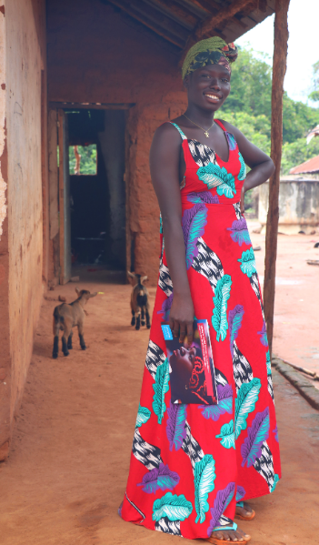  Nanica, 26 years old – Vila Baxada, in Fulacunda from Quinara Region  Nanica had heard about the dangers of female genital mutilation, but had not really understood the subject. One day, after leaving school, she met one of the activists from the NGO Rede de Ajuda working in her community, in Vila Baxada, and began to ask questions. In the local activities, supported by the UNFPA-UNICEF Joint Programme on the Elimination of Female Genital Mutilation in Guinea Bissau, she learned more about FGM, child marriage and violent practices against women. "It's very important that we talk about it," she says.  Now she knows what the consequences of female genital mutilation are and talks about it with her friends and neighbors. "It is not good and it causes a lot of problems and suffering for women".  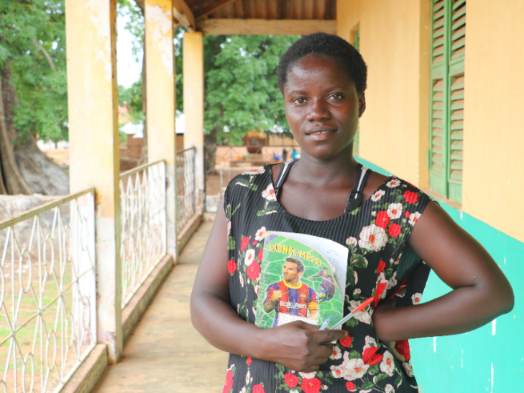  Sadio, 14 years old – Vila Baxada, in Fulacunda from Quinara Region  Sadio, 14 years, knew nothing about the dangers of female genital mutilation. "I learned it's not good because its bad for your health", she said.  She participated in the activities to mark the International Day of Zero Tolerance for Female Genital Mutilation, 6th of February, and was very happy to receive a dignity kit composed by basic personal hygiene products.  She was specifically shocked to hear about the risk of infections and the transmission of diseases, because she wants to be a doctor when she grows up. Now she is discussing everything she learned with her schoolmates and her friends. She already convinced some of them.  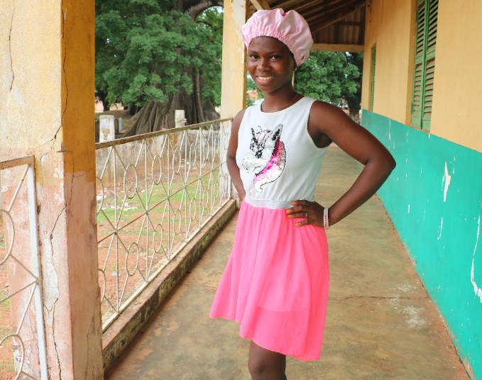  Cadi, 22 years old, Gã Banna, in Fulacuna from Quinara Region  Cadi enjoys participating in the community dialogues and this time she brought her youngest daughter, age 5. While listening to people discuss the dangers of female genital mutilation, forced marriage, and domestic violence, she braids the little girl's hair.  She thinks it is important to talk about these issues to raise awareness in the community. "I was a victim of female genital mutilation because I didn't know about it, but my daughters won't be," Cadi says. Her husband and neighbors now agree with her.  She is pleased that because of the support of the Joint UNFPA-UNICEF Program for the Elimination of Female Genital Mutilation in Guinea-Bissau some behaviors have already changed. "There are already a lot of things that we don't do anymore," Cadi says.  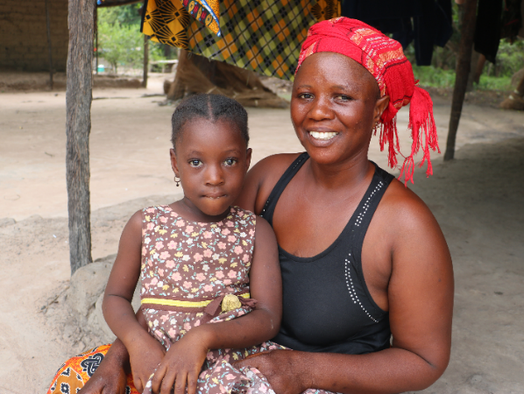  "I was one of the victims of child marriage and that was a barrier to achieving my dreams," Cadi says. "There were things I wanted to do but couldn't because of the marriage."  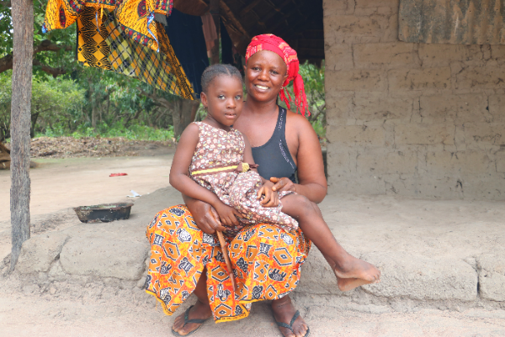  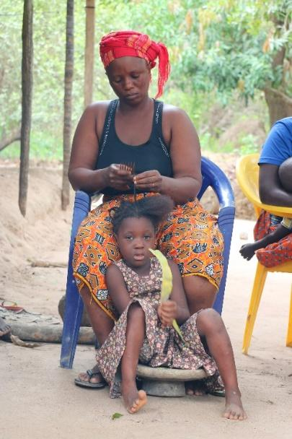
Link to more details
Visual assets (Photo/Video) | Quinara Region - FGM.CP Mission 26.6.2023

Activity 2
Activity Name
Description and/or outcomes

Link to more details
Visual assets (Photo/Video) | Provide link or attach in the email

